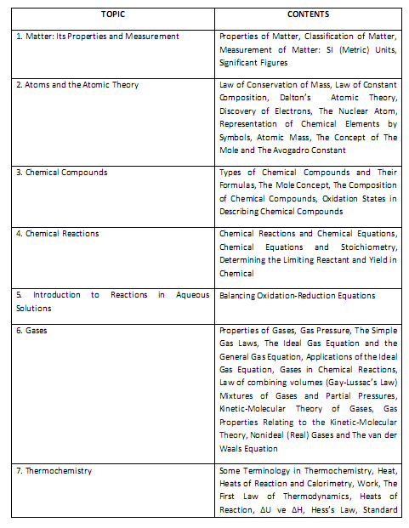

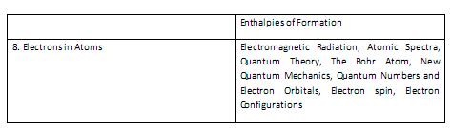
CONTENTS
The Periodic Table and Periodic Properties of the Elements
Introduction, Lewis Theory and Classification of Bonds, Ionic Bonding, Covalent Bonding, Multiple Covalent Bonds, Polar Covalent Bonds, Electronegativity, Writing Lewis Structures
Lewis Structures, Formal Charge, Exceptions to the Octet Rule, Resonance, Shapes of Molecules, VSEPR Theory, Molecule Examples, Bond Energies
Intermolecular Forces and Some Properties of Liquids, Viscosity, SurfaceTension, Vapor Pressure, Clasius –Clapeyron Equation, Critical Point, Phase Diagrams (water), van der Waals Forces, Hydrogen bond
Solutions, Solution Concentrations, Solution Process and Solution Enthalpy, Calculation of Solution heat for Ionic Solutions, Effects of Temperature and Pressure on Solubility, Solubility of Gases
Vapor Pressures of Solutions, Osmotic Pressure, Freezing Point-Depression, Boiling point-Elevation, Electrolyte Solutions
Dynamic Equilibrum, Equilibrium Constant Expression, Relationship Involving Equilibrium Constants, The Magnitude of an Equilibrium Constant, Predicting the Direction of Net Change, Altering Equilibrium Conditions: Le Chatelier’s Principle

EXPERIMENT 1: Investigation of the Rate of Chemical Reactions (NO: 1 in Lab Manual)
EXPERIMENT 2: Gases (NO: 3 in Lab Manual)
EXPERIMENT 3: Chemical Equilibrium (NO: 5 in Lab Manual)
EXPERIMENT 4: Determining of pH by Colorimetric Method (NO: 6 in Lab Manual)
EXPERIMENT 5: Acid- Base Reactions (NO: 9 in Lab Manual)

